CPN NPT – 2024
CLASS-11TH Maximum Marks: 150
Duration : 60 min.
General Instructions
- The test is of 60 mins. Duration and the maximum marks is 150.
- The question paper consists of 3 parts (Part 1: Physics, Part II: Chemistry, part III: Mathematics).
- Contains 20 multiple choice Questions. Each question has 4 choices (a), (b), (c) and (d), out of which ONE CHOICE is correct.
- No candidate is allowed to carry any textual material, printed or written, bits of papers, pager, mobile phone, any electronic device, etc. inside the examination room/hall.
- On completion of the test, the candidate must hand over t he Answer sheet to the Invigilator on duty in the Room/Hall. However, the candidates are allowed to take away this Test Booklet with them.
Marking Scheme
- +5 for correct answer, -1 (negative marking) for incorrect answer, 0 for all other cases.

Questions:-
Q.1 Which of these statements are correct for a particle going on a straight line?
Statement – I: If the velocity and acceleration have opposite sign, the object is slowing down.
Statement-II : If the position and velocity have opposite sign, the particle is moving towards the origin.
Statement –III : If the velocity is zero at an instant, the acceleration should also be zero at that instant.
Statement-IV : If the velocity is zero for a time interval, the acceleration is zero at any instant within the time interval.
a) I, II, III b) II, III, IV c) I, II, IV d) I, II, III, IV

Q.2 A car moving with a speed of 50 km/h can be stopped by brakes after at least 8 m. If the same car is moving at a speed of 100 km/h, the minimum stopping distance is :
a) 32m b) 18m c) 24m d) 16m

Q.3 If N1 is the normal reaction between 2 kg & 3 kg & N₂ is the normal reaction between 3 kg & ground, find N₁ , (Take g = 10 m/s²)
N₂
20N
1kg

2 kg

3 kg

a) 8 b) 5 c) 1 d) 2
5 8 2

___ ___ ___ ___
Q.4 The angle between (2A + 3B) and (2A x 3B) is:
a) π b) 0 c) π d π
2 6
Q.5 A ball dropped form a height reaches the same height after clastic impact with a glass floor. If the event is continued, the velocity-time graph is : (Consider vertically upward direction as positive)

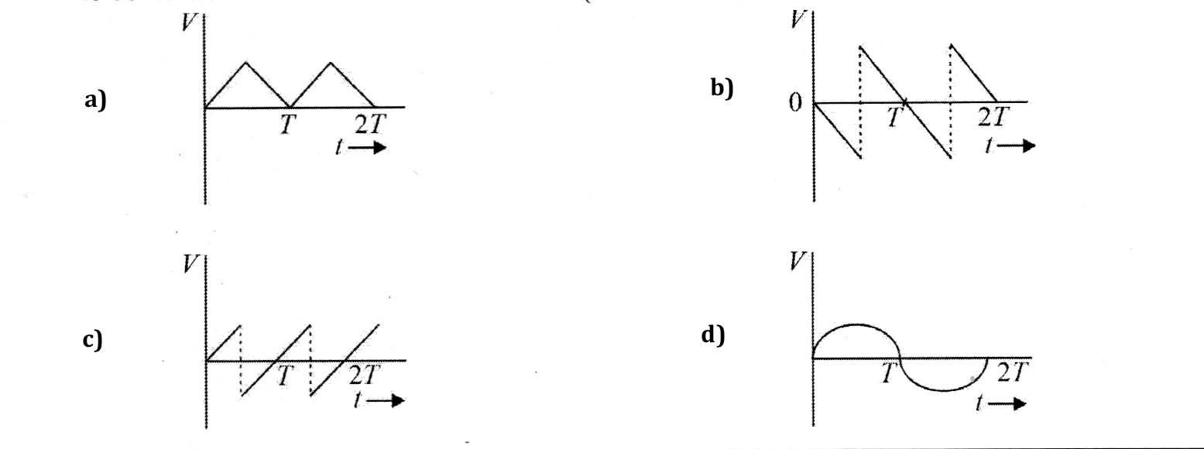

Q.6 A boy is cycling towards east with a speed of 6 m/s. A man who is initially 40m north of boy, is driving towards south with a speed of 8 m/s. The shortest distance between them will be:

a) 32m b) 24m c) 40m d) 0

Q.7 Consider the atomic number and position in the periodic table, identify correct increasing order of metallic character for elements: Si, Be, Mg, Na, P.
a) Si < P < Bc < Mg < Na b) P < Si < Be < Mg < Na
c) P < Si < Mg < Be < Na d) P < Si < Be < Na < Mg

Q.8 Which of the following is correct increasing order of dipole moment of BF₃, H₂O and HF ?
a) BF₃ <H₂O <HF b) HF < H₂O < BF₃
c) BF₃ < HF < H₂O d) HF < BF₃ < H₂O

Q.9 Which of the following statement(s) regarding electronegativity is/are correct ?
a) It is a quantitative measure of the ability of an atom in a chemical compound to attract shared electrons to itself.
b) The electronegativity of any given element is constant.
c) Its value depends upon the element to which it is bound.
d) It is the basis for determination of oxidation state of an element in a particular compound.
e) It provide a means of predicting the nature of force that holds a pair of atoms together.

a) a, b and c b) b, c and d c) c, d and e d) a, b, c, d and e

Q.10 The Principal reason that solid sodium hydroxide is not used as a primary standard for acid-base titration is that it:
a) Absorbs water form air b) Has a low molar mass
c) Reacts slowly with many acids d) Has same molecular mass and equalivalent mass

Q.11 Given below are two statements:
Statement-I : In chromium, maximum 14 electrons has one type of spin quantum nuber.
Statement-II : In chromium minimum 9 electrons has one type of spin quantum number.

In the light of above statements, choose the correct answer from the options given below.
a) Both Staement-I and Statement-II are correct.
b) Both Statement-I and Statement-II are incorrect.
c) Statement-I is correct but Statement-II is incorrect.
d) Statement-I is incorrect but Sttaement-II is correct.

Q.12. Which of the following is correct regarding electronic geometry of SF₆ ?
a) Regular octachedral
b) Planar hexagonal
c) Pentagonal bipyramidal with the lone pair occupying equatorial position
d) Distorted octahedral with the lone pair occupying the cap position.

Q.13. Given below are two statements:
Statement – I : NH₄ Cl is ionic compound.
Statement –II : NH₄ Cl has expanded octet.
In the light of above statements, choose the correct answer form the options given below.

a) Both Statement-I and Statement-II are true
b) Both Statement-I and Statement-II are false
c) Statement-I is true but Staement –II is false
d) Statement –I is false but Statement-II is true

Q.14. If x2 + 3 x + 5 = 0 and ax2 + bx + c = 0 have a common root and a, b, c ϵ N, the minimum value of a + b + c is:
a) 3 b) 9 c) 6 d) 12

Q.15. Maximum value of the function 5 is:
9x2 + 6x + 14

a) 5 b) 13 c) 5 d) 13
5 13

Q.16. Suppose that x < 0. Which of the following is equal to |2x - √(x-2)² |

a) x – 2 b) 3x-2 c) 3x+2 d) -3x+2

Q.17. The equation 5²x²⁻⁷x+⁷ = 25 has _____________________ root (s).
a) no real b) more than two real c) Only one real d) exactly two real

Q.18. The solutionof equation cos2 θ + sin θ + 1 = 0 lies in the interval.

a) ( - π , π ) b) ( π 3 π ) c) (3π 5 π ) d) ( 5 π 7 π )
4 4 4 4 4 4 4 4

Q.19. The sum of the first 20 terms common between the series 3+7+11+15+ …………. And 1+6+11+16+ …… is:

a) 4000 b) 4200 c) 4220 d) 4020

Q.20. If the 2nd, 5th and 9th terms of a non-constant arithmetic progression are in geometric progression, then the common ratio of this geometric progression is:

a) 3 b) 7 c) 8 d) 4
2 4 5 3

Q.21 Thre numbers a, b and c are in between 2 and 18 such that 2, a, b are in arithmetic progression and b,c, 18 are in geometric progression. If a + b + c = 25, then the value of c-a is:
a) 4 b) 3 c) 7 d) 0

Q.22. The number of values of x lying in (0, 2π) and satisfying the 4equation : sin x + sin 3X = 0 is are:
a) 2 b) 3 c) 4 d) 5
Q.23. One root of the equation cosx – x +1 = 0 lies in the internval:
a) (0, π ) b) ( -π , 0) c) (π , π ) d) ( π , 3π)
2 2 2 2

Q.24. At a certain moment of time, acceleration of the block A is 2 m/s2 upward and acceleration of block B is 3 m/s2 upward. The acceleration of block C is : (masses of pulleys and string are negligible)

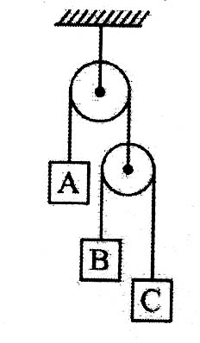

- 5 m/s2 upward b) 9 m/s2 downward
c) 8 m/s2 upward d) 7 m/s2 downward

Q.25. A smooth block is released from rest on a 45⁰ incline and then slides a distance d. The time taken to slide is n times as much to slide on a rough linclined than on a smooth inclide. The coefficient of friction is:

- µs = √1 – 1 b) µs = 1 – 1 c) µk = √1 – 1 d) µk = 1 – 1
n² n² n² n²

Q.26. Two blocks of masses 4 kg and 6 kg are attached to the two ends of a massless string passing over a
smooth fixed massless pulley. If the system is released from rest, the acceleration of the center of mass of
the system will be:

- g, vertically downwards b) g , vertically downwards
5
c) g , vertically downwars d) Zero
25

Q.27. A force F acts on a block kept on a rough horizontal surface. The mini9mum value of F such that the block
just moves is: (sin 37⁰ = 0.6, g = 10m/s²)
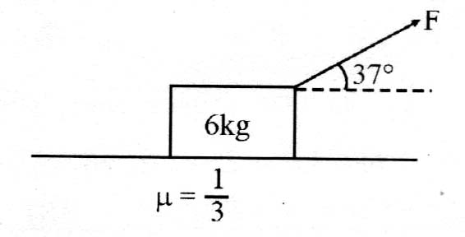
a) 33.33 N b) 20 N
c) 25 N d) 16 N

Q.28. The density of gas A is twice that of a gas B at the same temperature. The molecular weight of gas B is thrice that of A. The ratio of pressure acting on A and B will be:
a) 6:1 b) 7 : 6 c) 2:5 d) 1:4

Q.29. The root mean square velocity of an ideal gas at constant pressure varies with density (d) as:
a) d2 b) d c) √d d) 1
√d
Q.30. The enthalpy of gas phase trimerization of one mole of gaseous formaldehyde in (kJ/mole).

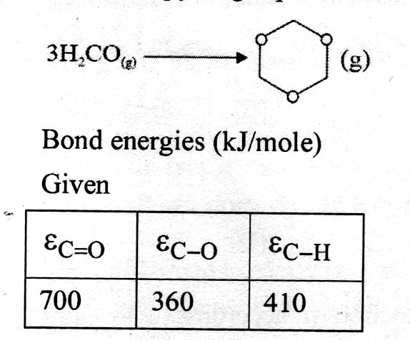
a) -20 b) – 60 c) -10 d) -50

